NULL-OHM-SPULE
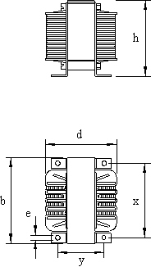
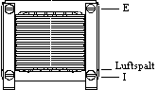

Kern | b  mm | h  mm | d  mm | x  mm | y  mm | e  mm
n106 | 106 | 94 | 88 | 84 | 60 | 5.8
n130 | 130 | 118 | 105 | 84 | 71 | 5.8
n150 | 150 | 132 | 107 | 122.5 | 71 | 7

